SWAPI Documentation

The Star Wars APIs

Table of Contents

SWAPI Overview 1

What is SWAPI? 1

Why should I use the SWAPI? 1

How to use the SWAPI? 1

Authentication 1

Headers 2

Return Status Code 2

Rate limits 2

SWAPI Reference—Endpoint: /people/id/ 2

Resource 2

Introduction 2

Base URL 2

Endpoint 2

Method 3

Request URL 3

Example URL 3

Path Parameters 3

Response Parameters 3

Sample Response 5

SWAPI Reference—Endpoint: /people/ 7

Resource 7

Introduction 7

Base URL 7

Endpoint 7

Method 7

Request URL 7

Query Field 7

Query Parameters 7

Response Parameters 8

Sample Response 10

SWAPI Overview

What is SWAPI?

The Star Wars API (SWAPI) is the world's first quantified and programmatically-accessible data source for all the data from the Star Wars canon universe! You can consume all the rich contextual stuff from the Star Wars universe using SWAPI.

Why should I use the SWAPI?

The SWAPI provides a wealth of data about the Star Wars universe to build applications. With the SWAPI, developers can access detailed Star Wars related data about people, planets, films, species and much more. From web and mobile applications to data analysis, the possibilities are limitless.

All the data is accessible through the SWAPI'S HTTP web API.

Visit <https://swapi.dev/> and <https://swapi.dev/documentation> to learn more.

Helper libraries for popular programming languages are also provided so you can consume SWAPI in your favourite programming language, in a style that suits you.

How to use the SWAPI?

Here are a few examples of what developers can build using the SWAPI:

Create a Star Wars encyclopedia to document the Star Wars universe and its characters.

Design a custom interactive map to explore the planets of the Star Wars universe.

Analyze the data to uncover patterns and insights about Star Wars films, characters, and species.

Design a search engine to query Star Wars related data.

Create a mobile app that displays information about the characters, films and species in the Star Wars universe.

Design a live score system specialized in providing stats related to the Star Wars films and characters.

Authentication

The SWAPI does not require authentication.

It is a completely open API. No authentication is required to query and get data. This also means that we've limited what you can do to just fetch (GET-ing) the data. If you find a mistake in the data, then tweet the person (<https://twitter.com/drchuck>) supporting the site.

Headers

Response Content-Type: application/json

Return Status Code

SWAPI uses conventional HTTP response codes to indicate the success or failure of an API request. In general: Codes in the 2xx range indicate success. Codes in the 4xx range indicate an error that failed given the information provided (for example, a required parameter was omitted, etc.)

Rate limits

SWAPI has a rate limit to prevent malicious abuse (as if anyone would abuse Star Wars data!) and to make sure our service can handle a potentially large amount of traffic. Rate limiting is done via IP address and is currently limited to 10,000 API request per day. This is enough to request all the data on the website at least ten times over. There should be no reason for hitting the rate limit.

SWAPI Reference—Endpoint: /people/id/

Resource

**people**

The people resource indicates an individual person or character within the Star Wars universe.

Introduction

This API fetches the details of a specific person or a character based on the id within the Star Wars universe.

Base URL

<https://swapi.py4e.com/api/>

The Base URL is the root URL for all the Star Wars APIs and provides information on all the available resources within the SWAPI.

If you ever make a request to SWAPI and you get back a 404 NOT FOUND response then check the Base URL first.

Endpoint

/people/id/ - get details of a specific person or character within the Star Wars universe people resource

Method

GET

Request URL

[https://swapi.py4e.com/api/people/{id}](https://swapi.py4e.com/api/people/%7bid%7d)

Example URL

<https://swapi.py4e.com/api/people/1/>

Path Parameters

|  |  |  |  |
| --- | --- | --- | --- |
| Parameters | Data Type | Examples of Values | Description |
| id | number | "1"  There are 87 people resources. Use values from 1 to 87. | Unique id of the person or the character from the people resource in the Star Wars Universe |

Response Parameters

| Parameters | Data Type | Examples of Values | Description |
| --- | --- | --- | --- |
| name | string | "Luke Skywalker" | The name of the person |
| height | string | "172" | The height of the person in centimetres |
| mass | string | "77" | The mass of the person in kilograms |
| hair_color | string | "blond";  "unknown" if not known or,  "n/a" if the person does not have hair | The hair color of the person |
| skin_color | string | "Fair" | The skin color of the person |
| eye_color | string | "blue";  "unknown" if not known or,  "n/a" if the person does not have eyes | The eye color of the person. |
| birth_year | string | 19BBY | The birth year of the person using the in-universe standard of BBY (Before the Battle of Yavin) or ABY (After the Battle of Yavin).  The Battle of Yavin occurs at the end of Star Wars, "episode IV: A New Hope." |
| gender | string | Either "Male", "Female" or "unknown", "n/a" if the person does not have a gender | The gender of this person. |
| homeworld | string | https://swapi.py4e.com/api/planets/1 | The URL of a planet resource, a planet that this person was born on or inhabits. |
| films | array | "films": [  "https://swapi.py4e.com/api/films/1/", "https://swapi.py4e.com/api/films/2/"  ] | An array of film resource URLs that this person has been in. |
| species | array | "species": [  "https://swapi.py4e.com/api/species/1/"  ] | An array of species resource URLs that this person belongs to. |
| vehicles | array | "vehicles": [  "https://swapi.py4e.com/api/vehicles/14/",  "https://swapi.py4e.com/api/vehicles/30/"  ] | An array of vehicle resource URLs that this person has piloted. |
| starships | array | "starships": [  "https://swapi.py4e.com/api/starships/12/", "https://swapi.py4e.com/api/starships/22/"  ] | An array of starship resource URLs that this person has piloted. |
| created | string | 2014-12-09T13:50:51.644000Z | the ISO 8601 date format of the time that this resource was created. |
| edited | string | 2014-12-20T21:17:56.891000Z | the ISO 8601 date format of the time that this resource was edited. |
| url | string | https://swapi.py4e.com/api/people/1/ | the hypermedia URL of this resource. |

Sample Response

|  |
| --- |
| {  "name": "Luke Skywalker",  "height": "172",  "mass": "77",  "hair_color": "blond",  "skin_color": "fair",  "eye_color": "blue",  "birth_year": "19BBY",  "gender": "male",  "homeworld": "https://swapi.py4e.com/api/planets/1/",  "films": [  "https://swapi.py4e.com/api/films/1/",  "https://swapi.py4e.com/api/films/2/",  "https://swapi.py4e.com/api/films/3/",  "https://swapi.py4e.com/api/films/6/",  "https://swapi.py4e.com/api/films/7/"  ],  "species": [  "https://swapi.py4e.com/api/species/1/"  ],  "vehicles": [  "https://swapi.py4e.com/api/vehicles/14/",  "https://swapi.py4e.com/api/vehicles/30/"  ],  "starships": [  "https://swapi.py4e.com/api/starships/12/",  "https://swapi.py4e.com/api/starships/22/"  ],  "created": "2014-12-09T13:50:51.644000Z",  "edited": "2014-12-20T21:17:56.891000Z",  "url": "https://swapi.py4e.com/api/people/1/"  } |

-------------------------------------------------------------------------------------------------------------------------------

Endpoint: /people/id/

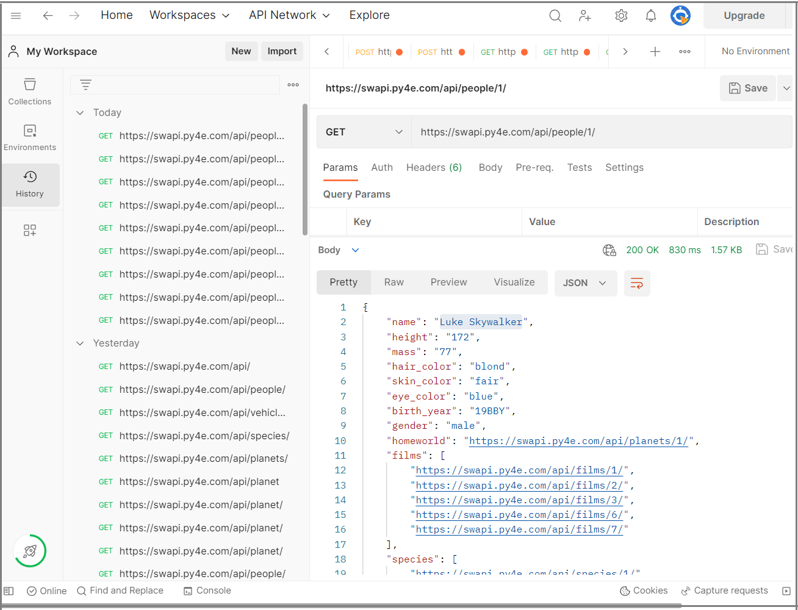

SWAPI Reference—Endpoint: /people/

Resource

**people**

A people resource is an individual person or character within the Star Wars universe.

Introduction

This API lists the details of all the characters and people within the Star Wars universe.

Base URL

<https://swapi.py4e.com/api/>

The Base URL is the root URL for all the Star Wars APIs and provides information on all the available resources within the SWAPI.

If you ever make a request to SWAPI and you get back a 404 NOT FOUND response then check the Base URL first.

Endpoint

/people/ - get all the people resources within the Star Wars universe

Method

GET

Request URL

<https://swapi.py4e.com/api/people/>

Query Field

[https://swapi.py4e.com/api/people/?search={name}](https://swapi.py4e.com/api/people/?search=%7bname%7d)

Example

<https://swapi.py4e.com/api/people/?search=luke>

Query Parameters

|  |  |  |  |
| --- | --- | --- | --- |
| Parameters | Data Type | Examples of Values | Description |
| name | string | "luke" | The person's name or the character name by which the resource data is filtered. |

Response Parameters

The Response parameters for the Request URL, <https://swapi.py4e.com/api/people/>.

| Parameters | Data Type | Examples of Values | Description |
| --- | --- | --- | --- |
| count | number | "87"  At present there are 87 people resources.  However, the count may increase if new persons or characters are added in the future. | Total count of the people resource in the Star Wars Universe |
| next | string | "https://swapi.py4e.com/api/people/?page=2" | The URL of the next people-resource page |
| previous | string | "https://swapi.py4e.com/api/people/?page=1"  The value is "null" when you are on page "1". | The URL of the previous people-resource page |
| results.name | string | "Luke Skywalker" | The name of the person |
| results.height | string | "172" | The height of the person in centimetres |
| results.mass | string | "77" | The mass of the person in kilograms |
| results.hair_color | string | "blond";  "unknown" if not known or,  "n/a" if the person does not have hair | The hair color of the person |
| results.skin_color | string | "Fair" | The skin color of the person |
| results.eye_color | string | "blue";  "unknown" if not known or,  "n/a" if the person does not have eyes | The eye color of the person. |
| results.birth_year | string | 19BBY | The birth year of the person using the in-universe standard of BBY (Before the Battle of Yavin) or ABY (After the Battle of Yavin).  The Battle of Yavin occurs at the end of Star Wars, "episode IV: A New Hope." |
| results.gender | string | Either "Male", "Female" or "unknown", "n/a" if the person does not have a gender | The gender of this person. |
| results.homeworld | string | "https://swapi.py4e.com/api/planets/1" | The URL of a planet resource, a planet that this person was born on or inhabits. |
| results.films | array | "films": [  "https://swapi.py4e.com/api/films/1/", "https://swapi.py4e.com/api/films/2/"  ] | An array of film resource URLs that this person has been in. |
| results.species | array | "species": [  "https://swapi.py4e.com/api/species/1/"  ] | An array of species resource URLs that this person belongs to. |
| results.vehicles | array | "vehicles": [  "https://swapi.py4e.com/api/vehicles/14/",  "https://swapi.py4e.com/api/vehicles/30/"  ] | An array of vehicle resource URLs that this person has piloted. |
| results.starships | array | "starships": [  "https://swapi.py4e.com/api/starships/12/", "https://swapi.py4e.com/api/starships/22/"  ] | An array of starship resource URLs that this person has piloted. |
| results.created | string | 2014-12-09T13:50:51.644000Z | the ISO 8601 date format of the time that this resource was created. |
| results.edited | string | 2014-12-20T21:17:56.891000Z | the ISO 8601 date format of the time that this resource was edited. |
| results.url | string | https://swapi.py4e.com/api/people/1/ | the hypermedia URL of this resource. |

Sample Response

|  |
| --- |
| {  "count": 87,  "next": "https://swapi.py4e.com/api/people/?page=2",  "previous": null,  "results": [  {  "name": "Luke Skywalker",  "height": "172",  "mass": "77",  "hair_color": "blond",  "skin_color": "fair",  "eye_color": "blue",  "birth_year": "19BBY",  "gender": "male",  "homeworld": "https://swapi.py4e.com/api/planets/1/",  "films": [  "https://swapi.py4e.com/api/films/1/",  "https://swapi.py4e.com/api/films/2/",  "https://swapi.py4e.com/api/films/3/",  "https://swapi.py4e.com/api/films/6/",  "https://swapi.py4e.com/api/films/7/"  ],  "species": [  "https://swapi.py4e.com/api/species/1/"  ],  "vehicles": [  "https://swapi.py4e.com/api/vehicles/14/",  "https://swapi.py4e.com/api/vehicles/30/"  ],  "starships": [  "https://swapi.py4e.com/api/starships/12/",  "https://swapi.py4e.com/api/starships/22/"  ],  "created": "2014-12-09T13:50:51.644000Z",  "edited": "2014-12-20T21:17:56.891000Z",  "url": "https://swapi.py4e.com/api/people/1/"  },  {  "name": "C-3PO",  "height": "167",  "mass": "75",  "hair_color": "n/a",  "skin_color": "gold",  "eye_color": "yellow",  "birth_year": "112BBY",  "gender": "n/a",  "homeworld": "https://swapi.py4e.com/api/planets/1/",  "films": [  "https://swapi.py4e.com/api/films/1/",  "https://swapi.py4e.com/api/films/2/",  "https://swapi.py4e.com/api/films/3/",  "https://swapi.py4e.com/api/films/4/",  "https://swapi.py4e.com/api/films/5/",  "https://swapi.py4e.com/api/films/6/"  ],  "species": [  "https://swapi.py4e.com/api/species/2/"  ],  "vehicles": [],  "starships": [],  "created": "2014-12-10T15:10:51.357000Z",  "edited": "2014-12-20T21:17:50.309000Z",  "url": "https://swapi.py4e.com/api/people/2/"  }  ]  } |

-------------------------------------------------------------------------------------------------------------------

Endpoint: /people/

